Improving Grammar and
Vocabulary

Match the words with their definitions.

1. release

2. goal

3. take place

4. crewmate

5. sabotage

6. covertly

7. task

8. sequel
a. secretly, or in a hidden way

b. a book, film, or play that continues the story of a previous book, etc.

c. to make a record, product or movie ready for people to buy or see

d. a small job or duty

e. to spoil someone’s plans or efforts in order to prevent them from being successful

f. something that you want to do or achieve in the future

g. to happen

h. a member of the same crew

Now, read the text about “Among us”. For each question,
choose the correct answer 1, 2 or 3.

Among us

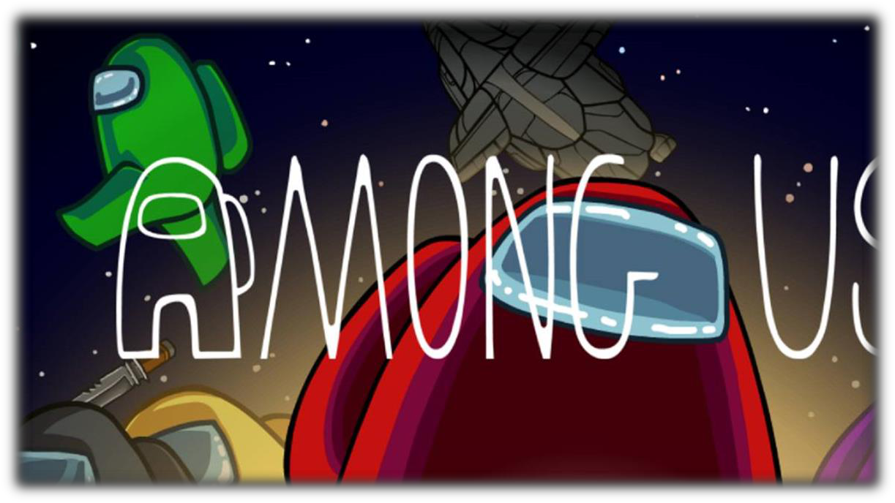

Among Us is an online multiplayer social deduction
1.play 2. computer 3. game developed and published by an American game studio.
The game 1.takes 2. has 3. makes place in a space-themed setting, in which 1.players 2. gamers 3. person each take
1. the 2. on 3. care one of two roles, most being Crewmates, and an already set number being Impostors
The 1. goal 2. funny 3. responsibility of the Crewmates is to identify the Impostors 1.play 2. eliminate 3. escape them, and complete tasks around the map; the Impostors' goal is to covertly
1. sabotage 2. run 3. fight and eliminate the Crewmates before they complete all their tasks.Through a plurality vote, players believed to be Impostors maybe 1. destroyed 2. removed 3. canceled from the game. If all Impostors are eliminated or all tasks are completed, the Crewmates 1.players 2. gamers 3. person; if there is an equal number of Impostors and Crewmates, or if a critical sabotage goes unresolved, the Impostors win.
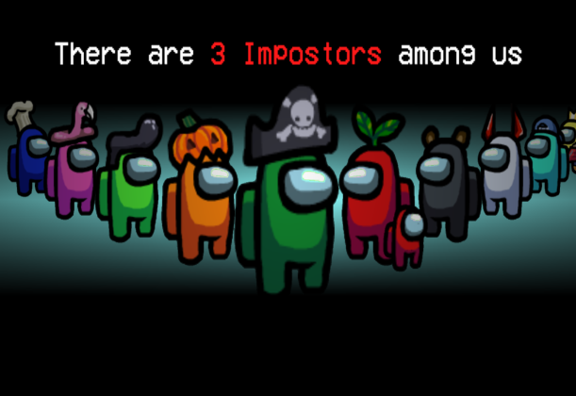
Among us was released on June 15, 2018, however it became popular
1. with 2. between 3. in
teenagers all over the world in 2020, due to many well-known Twitch streamers and YouTubers
1. such us 2. example 3. as Ibai Llanos, Rubius, TheGrefg,
AuronPlay or Willyrex started to play it. In response to the game's popularity, a sequel, Among Us 2, was 1. announced 2. sold 3. given in August 2020. However, a month later in September, the planned sequel was 1. deleted 2. canceled 3. end as the team instead decided to focus on 1. changing 2. selling 3. improving the original game.

