The Present Continuous Tense is





**Choose the correct option**

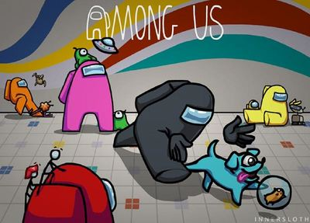

**1. The dog ________________**

1. is eating.
2. is walking.
3. is sleeping.

**2. They ________________**



1. is watching a video.
2. am watching a video.
3. are watching a video.

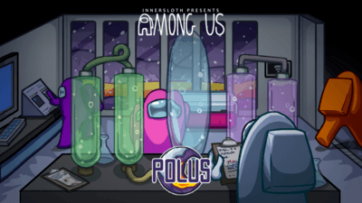**3. Are they working?**

1. Yes, they are.
2. No, they aren’t.
3. Yes, they aren’t.

**4. Is he flying?**



1. No, he isn’t.
2. Yes, he is.
3. No, he is.

**5. He _______________ with his friend.**



1. are running
2. am running
3. is running

6. They _________________ for a mission.

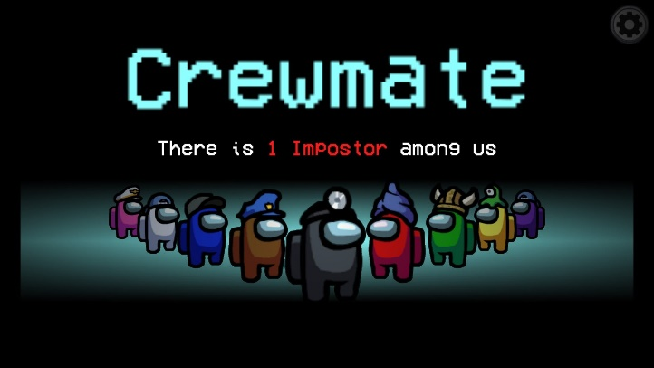

1. is waiting
2. am waiting
3. are waiting

